THEME: BOLD, STRONG AND COURAGEOUS

LESSONS ABOUT THE EVENTS THAT LED TO EASTER
The lessons we learn will help us explore all the events that led to Easter, why they happened and why it matters to us so that we can apply these lessons as Christians/Believers.

MOVERS SHAKERS- 9-12 YEARS
DATE | 30TH APRIL 2025
TOPIC | MATTHEW 21:1-11  Jesus Enters Jerusalem (Palm Sunday)
LESSON OVERVIEW | Jesus entering Jerusalem was the first step into Easter. It was the fulfilment of the prophecy that Prophet Zechariah made about Jesus our King entering Jerusalem on a donkey. God’s people welcomed Him by laying clothes down on the path He used and waving palm branches in worship to the Messiah.
TAKE AWAY | This event is reminder to welcome Jesus and genuinely worship Him as the King of Kings and Lord of Lords.
PREPARATION | Read Matthew 21:1-11, Zechariah 9:9 and Psalm 118:26  Come along with a Palm branch or an extra cloth.
GAME | Pin the Tail on the donkey  Preparation: Obtain a donkey poster (or print one), paper tails with pins or thumbtacks, and blindfolds.  Setup: Hang the donkey poster on a wall.  Gameplay:  - Blindfold a player and spin them around several times.  - Give the player a paper tail and guide them towards the donkey poster.  - The player attempts to pin the tail onto the donkey where they think it belongs.  - Repeat with each player.  - The player whose tail is closest to the "correct" spot (usually marked with an "X" or the donkey's natural tail position) wins.
WORSHIP LEADER | Turn to the person next to you and ask them, “If you had a birthday party and invited a very important person, how would you welcome them when they showed up?”  Imagine if it were Jesus. How would you welcome Jesus? We welcome Jesus every day when we pray to Him, when we sing songs of praise to Him. Let’s welcome Him right now. He is indeed the only way to God our Father.  - Only Way – Planet Shakers  - New Life (Whole New World) – Watoto Kids Connect  Prayer: Jesus, we welcome you today. Forgive us for the things we done, said and thought about that have not pleased You. Come and make us whole today, in Jesus’ Name Amen.  - Mighty Name Of Jesus- Belonging Co. (Chorus & Bridge)
PRAYER | Jesus, Your Name is powerful, we find healing in Your Name. Thank you for being or Lord and Savior.  As we learn from your Word today, we ask the Holy Spirit to guide us and lead us, in Jesus’ Name. Amen.
BIG WORD | Last week we began lessons around the events that took place towards Easter.  Easter is important because it is the time God fulfilled the promise He made to Adam and Eve when they disobeyed God and brought sin into the world. God loved us so much that He sent Jesus as the perfect sacrifice for our sins to be forgiven and for us to be God’s friends.  The very first event that led us to Easter was the day Jesus entered Jerusalem on a donkey. Today, we call it “PALM SUNDAY”.  This was a prophecy that was made in Zechariah 9:9 “Rejoice, people of Jerusalem. Shout for joy, people of Jerusalem. Your king is coming to you. He does what is right, and he saves. He is gentle and riding on a donkey. He is on the colt of a donkey.”  The sign God’s people needed was to see Jesus, riding on a donkey. That’s how they knew that He was the One that was promised to come to save them.  God’s people welcomed Him in a special way, they laid clothes on the ground, they waved palm branches, they worshipped Him with shout of joy. In fact, the Pharisees were complaining, and this was His response to them in Luke 19:30, “I tell you, if my followers don’t say these things, then the stones will cry out.”  What are you doing to welcome Jesus every day?  Let’s watch this video  https://www.youtube.com/watch?v=DW-_0iH8EHk  Wow! So, it was such a celebration of excitement. I hope you’re ready to get into your crews, to discuss.
CREW TIME
BIBLE MAZE | 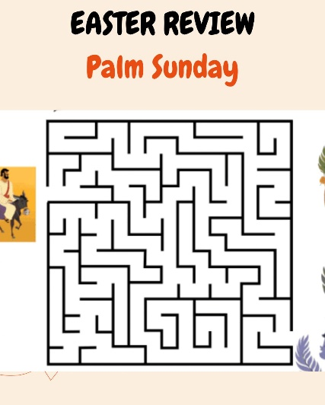  Welcome to our crew (say the name of the crew).  Before we discuss, let’s help Jesus find the people who are ready to welcome Him.
DISCUSSION  Use the palm branches in your acting.  Read Matthew 21:1-11 | That was fun, helping Jesus.  - How did people know that Jesus was the King and Messiah that they were waiting for?  Read Zechariah 9:9  - How did God’s people welcome Jesus? (Please act this out with the children)  Let’s read, Matthew 21:8-11  “Many people spread their coats on the road before Jesus. Others cut branches from the trees and spread them on the road. ⁹ Some of the people were walking ahead of Jesus. Others were walking behind him. All the people were shouting,  “Praise^{[a]} to the Son of David! God bless the One who comes in the name of the Lord!  Praise to God in heaven!” ¹⁰ Then Jesus went into Jerusalem. The city was filled with excitement. The people asked, “Who is this man?” ¹¹ The crowd answered, “This man is Jesus. He is the prophet from the town of Nazareth in Galilee.”  - How can you welcome Jesus today?  If you still have time, play a dance song for your children to worship Jesus.
MEMORY VERSE | Matthew 21:9b  “Blessed is He who comes in the name of the Lord!”
CONCLUSION | Jesus entering Jerusalem marked the beginning of the last days of Jesus before He died on the cross for our sins to be forgiven, for us to be reconciled back to God.  We will always celebrate this day because it’s a reminder for us to welcome Jesus every day through prayer, through reading His Word, through our worship to Him.  Let’s Pray.
WEEKLY CHALLENGE | Read and Study Luke 22:7–38
GAME OR SONG | One Way- Hillsong  Tag of War

