THEME: BOLD, STRONG AND COURAGEOUS

LESSONS ABOUT THE EVENTS THAT LED TO EASTER
The lessons we learn will help us explore all the events that led to Easter, why they happened and why it matters to us so that we can apply these lessons as Christians/Believers.

HEROES- 5-6 YEARS
DATE | 30TH APRIL 2025
TOPIC | MATTHEW 21:1-11  Palm Sunday (Jesus Enters Jerusalem)
LESSON OVERVIEW | Jesus entering Jerusalem was the first step into Easter. It was a promise that God made to His people about Jesus our King entering Jerusalem on a donkey.  God’s people welcomed Him by laying clothes down on the path He used and waving palm branches in worship to the Messiah.
TAKE AWAY | We need to welcome Jesus by worshipping Him as the King of Kings and Lord of Lords.
PREPARATION | Read Matthew 21:1-11, Zechariah 9:9  Come along with a Palm branch or an extra cloth.
GAME | Pin the Tail on the donkey  Preparation: Obtain a donkey poster (or print one), paper tails with pins or thumbtacks, and blindfolds.  Setup: Hang the donkey poster on a wall.  Gameplay:  - Blindfold a player and spin them around several times.  - Give the player a paper tail and guide them towards the donkey poster.  - The player attempts to pin the tail onto the donkey where they think it belongs.  - Repeat with each player.  - The player whose tail is closest to the "correct" spot (usually marked with an "X" or the donkey's natural tail position) wins.
PRAYER | Jesus, Your Name is powerful, we find healing in Your Name. Thank you for being or Lord and Savior.  As we learn from your Word today, we ask the Holy Spirit to guide us and lead us, in Jesus’ Name. Amen.
BIG WORD | Last week we began lessons around the things that happened towards Easter.  Easter is important because it is the time God kept the promise He made to Adam and Eve when they disobeyed God, and sin came into the world. God loved us so much that He sent Jesus to die for our sins, so that we can be God’s friends.  The very first thing that happened that led us to Easter was the day Jesus entered Jerusalem on a donkey. Today, we call it “PALM SUNDAY”.  This was a promise that God made in Zechariah 9:9 “Rejoice, people of Jerusalem. Shout for joy, people of Jerusalem. Your king is coming to you. He does what is right, and he saves. He is gentle and riding on a donkey. He is on the colt of a donkey.”  The sign God’s people needed was to see Jesus, riding on a donkey.  (Ask the children to make the sound of a donkey)  Jesus on a donkey is how they knew that He was the One that was promised to come to save them.  God’s people welcomed Him in a special way, they laid clothes on the ground, they waved palm branches, they worshipped Him with shouts of joy.  In fact, some bad people were complaining, and this is what Jesus said to them in Luke 19:30, “I tell you, if my followers don’t say these things, then the stones will cry out.”  Let’s watch this video  https://www.youtube.com/watch?v=z-39h0xYqdE  Wow! So, it was such a celebration of excitement. I hope you’re ready to get into your crews, to discuss.
CREW TIME
BIBLE MAZE | 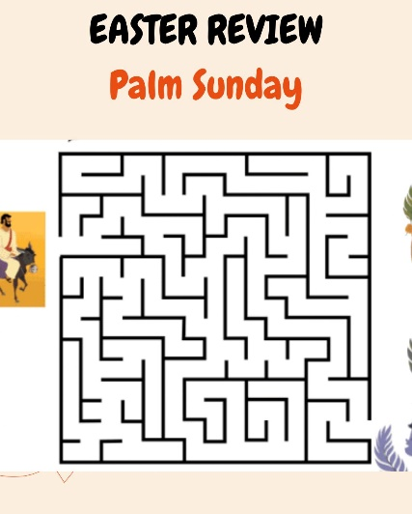  Welcome to our crew (say the name of the crew).  Before we discuss, let’s help Jesus find the people who are ready to welcome Him.
DISCUSSION  Use the palm branches in your acting.  Read Matthew 21:1-11 | That was fun, helping Jesus.  - How did people know that Jesus was the King and Messiah that they were waiting for?  They saw Jesus riding on a donkey, so they welcomed Him with rejoicing and shouting, Hosanna.  - How did God’s people welcome Jesus? (Please act this out with the children)  Let’s read, Matthew 21:8-11  “Many people spread their coats on the road before Jesus. Others cut branches from the trees and spread them on the road. ⁹ Some of the people were walking ahead of Jesus. Others were walking behind him. All the people were shouting,  “Praise^{[a]} to the Son of David! God bless the One who comes in the name of the Lord!  Praise to God in heaven!” ¹⁰ Then Jesus went into Jerusalem. The city was filled with excitement. The people asked, “Who is this man?” ¹¹ The crowd answered, “This man is Jesus. He is the prophet from the town of Nazareth in Galilee.”  - How can you welcome Jesus today?  By using your mouth (touch your mouth) to sing to Jesus.  By using your hands (wave your hands) to worship Jesus.  By using your feet (stomp your feet) to dance for Jesus.  If you still have time, play a dance song for your children to worship Jesus.
MEMORY VERSE | Matthew 21:9b  “Blessed is He who comes in the name of the Lord!”
CONCLUSION | Jesus entering Jerusalem on a donkey was the beginning of the last days of Jesus before He died on the cross for our sins so that we can be God’s friends.  We will always celebrate this day because it’s a reminder for us to welcome Jesus every day by talking to Him in prayer, by reading the Bible and by singing to Him.  Let’s Pray.
WEEKLY CHALLENGE | Ask your Parents or Guardians to help you read and study Luke 22:7–38 for our next Bible Story.
GAME OR SONG | One Way- Hillsong  Tag of War

